**PetCare+ –>Specialized Veterinary Treatment Slot Booking System**

**PHASE 6**

**1 — Create Custom Tabs for your objects**

* **What it is:** A tab is like a menu button in your app (Pets, Slots, Treatments).
* **Usage:** Lets Receptionists/Doctors easily open and manage records of Pets, Slots, and Treatments.
* **How it helps:** Without tabs, your custom objects are hidden. With tabs, users can search, list, and create records quickly.

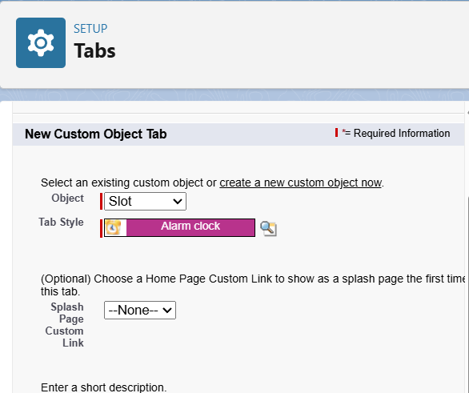





**2 — Create / Edit the PetCare+ Lightning App (App Manager)**

• **What it is:** A container (like a “package”) where you group tabs, reports, dashboards.

• **Usage:** Organizes everything into one app called **PetCare+** instead of users navigating all over Salesforce.

• **How it helps:** Doctors/Receptions log into PetCare+ → see only the tools they need (Slots, Pets, Treatments, Reports, Dashboards).

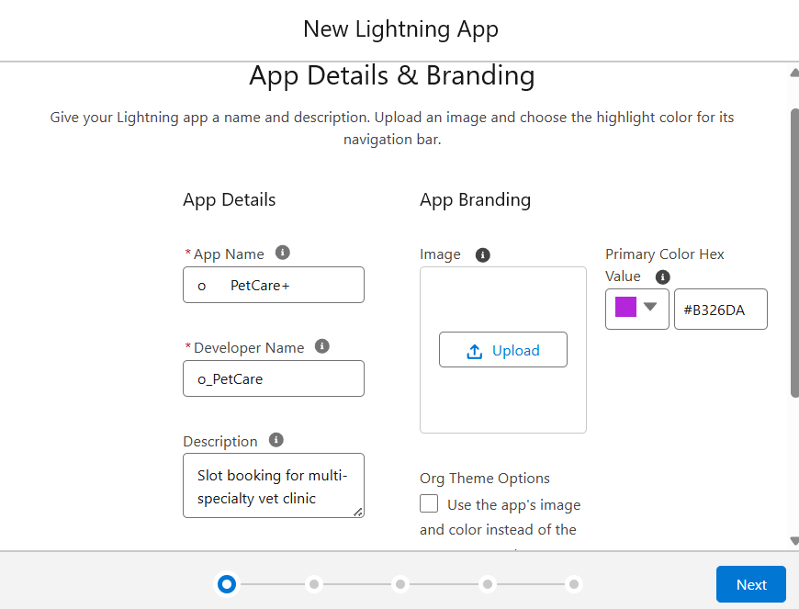

**3. Reports**

1. **What it is:** Lists and summaries of your data .
2. **Usage:** e.g., Slots by Doctor, Monthly Appointment Volume.
3. **How it helps:** Receptionist/Admin can track how many appointments each doctor has, how busy the clinic is per month.
   * 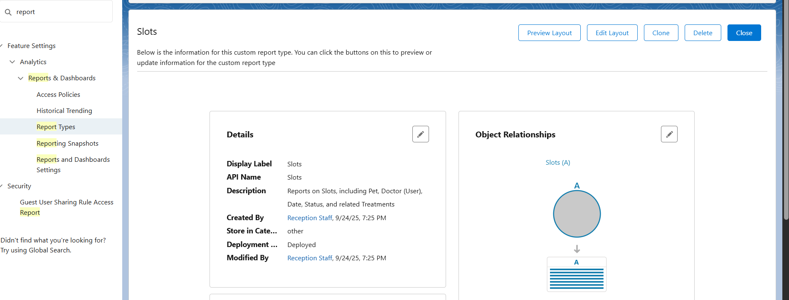

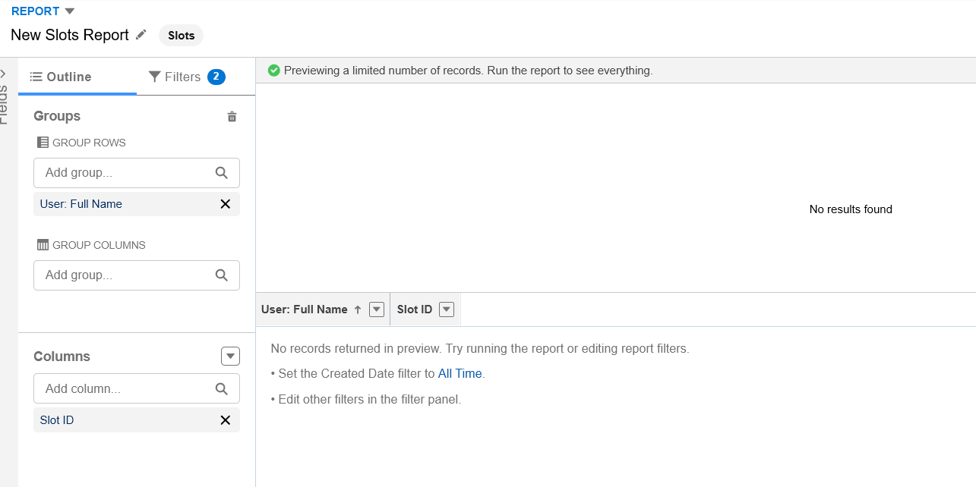

**4— Create a Dashboard and add charts**

• **What it is:** Visual layer on top of reports (charts, graphs, KPIs).

• **Usage:** You pin reports (Slots by Doctor, Monthly Volume) into one view.

• **How it helps:** Admins can see clinic performance at a glance, make staffing decisions, track growth.

